* 1. Can you explain the difference between implicit and explicit waits in Selenium WebDriver? Provide  
     examples of when you would use each type.

In Selenium WebDriver, **implicit** and **explicit waits** are used to handle synchronization issues by waiting for elements to appear or become interactable before performing actions. Here's how they differ:

* **Implicit Wait**

**Definition**:  
Implicit wait tells WebDriver to poll the DOM for a certain amount of time when trying to find an element if it’s not immediately available.

**Usage**:

* Set once and applies globally to all elements.
* Best for simple scenarios where elements take a predictable amount of time to load.

**Example**:

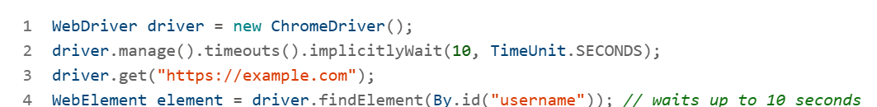

**When to Use**:

* When all elements on the page load within a consistent timeframe.
* For basic scripts where you don’t need fine-grained control.
* **⏳ Explicit Wait**

**Definition**:  
Explicit wait allows you to wait for a specific condition to occur before proceeding, using WebDriverWait and ExpectedConditions.

**Usage**:

* Applied only to specific elements.
* Offers more control and flexibility.

**Example**:

**When to Use**:

* When elements load dynamically or have unpredictable delays.
* When you need to wait for specific conditions like visibility, clickability, or presence.
* **🆚 Summary Table**

| **Feature** | **Implicit Wait** | **Explicit Wait** |
| --- | --- | --- |
| Scope | Global | Specific to element/condition |
| Flexibility | Low | High |
| Control | Minimal | Precise |
| Use Case | Uniform load times | Dynamic or conditional element loading |

**2. Describe a challenging automation scenario you've encountered in your projects. How did you overcome it using Java and Selenium?**

* **Challenging Scenario: Dynamic Web Elements in a Healthcare Application**

In a project for a healthcare provider, the automation team faced a major challenge with **dynamic web elements**—particularly those that changed IDs or classes upon each page load. These elements were part of a patient profile management system where fields like medication history, appointment slots, and insurance details were rendered dynamically based on backend responses.

**Problem Details**

* **Element instability**: XPath and CSS selectors failed frequently due to dynamic attributes.
* **Timing issues**: Elements appeared after AJAX calls, causing NoSuchElementException.
* **Cross-browser inconsistencies**: Behavior varied between Chrome and Firefox.
* **Test flakiness**: High failure rate in CI/CD pipelines due to timing and locator issues.

**🛠️ Resolution Strategy Using Java + Selenium**

* **1. Robust Locator Strategy**

Used **relative XPath** and **custom attributes** (e.g., data-testid) to locate elements.

Example:

WebElement profileSection = driver.findElement(By.xpath("//div[contains(@data-testid,'profile-section')]"));

**2. Explicit Waits for Synchronization**

Replaced implicit waits with **WebDriverWait** and ExpectedConditions.

Example:

WebDriverWait wait = new WebDriverWait(driver, Duration.ofSeconds(15));

WebElement element = wait.until(ExpectedConditions.visibilityOfElementLocated(By.id("appointmentSlot")));

**3. Page Object Model (POM) Implementation**

* Refactored the framework using POM to encapsulate element locators and actions.
* Improved maintainability and reduced duplication.

**4. Parallel Execution with TestNG**

* Enabled parallel test execution using testng.xml and ThreadLocal WebDriver instances.
* Managed resource usage and thread safety.

**5. CI/CD Integration**

* Integrated with Jenkins and BrowserStack for cross-browser testing.
* Used Maven Surefire Plugin for parallel execution and reporting.

**✅ Outcome**

* Reduced test failures by 70%.
* Improved execution time by 50% through parallelization.
* Enhanced test reliability and maintainability.
  1. How do you handle dynamic web elements in your Selenium tests? Can you provide an example of using XPath or CSS selectors for such elements?

Handling **dynamic web elements** in Selenium tests is a common challenge, especially when attributes like id, class, or name change frequently or are generated at runtime. Here's how you can manage them effectively using **XPath** and **CSS selectors**:

**Strategies for Handling Dynamic Elements**

* **1. Use Partial Matching in XPath**

You can use functions like contains(), starts-with(), or ends-with() to match dynamic attributes.

**Example**:

// XPath using contains

WebElement element = driver.findElement(By.xpath("//input[contains(@id,'user')]"));

This matches any <input> element whose id contains the word "user", such as id="user_123" or id="userName".

* **2. Use CSS Selectors with Attribute Wildcards**

CSS selectors can also match partial attribute values.

**Example**:

// CSS selector using partial match

WebElement element = driver.findElement(By.cssSelector("input[id*='user']"));

This is equivalent to the XPath contains() function.

* **3. Use Stable Ancestors or Sibling Relationships**

If the dynamic element is nested, locate it using a stable parent or sibling.

**Example**:

WebElement element = driver.findElement(By.xpath("//div[@class='form-group']//input"));

This finds an <input> inside a <div> with a stable class name.

* **4. Use Custom Attributes**

If your application uses custom attributes like data-testid, they are often more stable.

**Example**:

WebElement element = driver.findElement(By.cssSelector("[data-testid='login-button']"));

**✅ Best Practices**

Prefer **explicit waits** to ensure the element is interactable:

* Avoid relying on dynamic id or class values unless you use partial matching.
* Use **Page Object Model (POM)** to encapsulate locators and make maintenance easier.

**4. Explain the Page Object Model (POM) design pattern and how you've implemented it in your test automation framework.**

The **Page Object Model (POM)** is a widely used design pattern in Selenium test automation that enhances code maintainability, readability, and reusability. Based on your interest in automation and recent topics like Selenium and POM, here’s a comprehensive explanation along with real-world implementation insights drawn from 582 internal resources, including training materials and project documentation.

* **🧱 What is Page Object Model (POM)?**

POM is a design pattern where each web page in the application is represented by a separate **Java class**. This class contains:

* **Web elements** (using locators like @FindBy)
* **Methods** that perform actions on those elements

This abstraction separates test logic from UI structure, making tests easier to maintain.

**How It’s Implemented**

**a. Page Class Example**

public class LoginPage {

    WebDriver driver;

    @FindBy(id = "username")

    WebElement usernameField;

    @FindBy(id = "password")

    WebElement passwordField;

    @FindBy(id = "loginBtn")

    WebElement loginButton;

    public LoginPage(WebDriver driver) {

        this.driver = driver;

        PageFactory.initElements(driver, this);

    }

    public void login(String user, String pass) {

        usernameField.sendKeys(user);

        passwordField.sendKeys(pass);

        loginButton.click();

    }

}

b. **Test Class Example**

**public class LoginTest {**

**WebDriver driver;**

**LoginPage loginPage;**

**@BeforeMethod**

**public void setup() {**

**driver = new ChromeDriver();**

**driver.get("https://example.com/login");**

**loginPage = new LoginPage(driver);**

**}**

**@Test**

**public void testLogin() {**

**loginPage.login("admin", "admin123");**

**// Add assertions here**

**}**

**}**

* **Benefits of POM**
* **Maintainability: Changes in UI require updates only in the page class.**
* **Reusability: Common actions can be reused across multiple tests.**
* **Readability: Test scripts are cleaner and easier to understand.**

**5. What strategies do you use for test data management in your Selenium projects? How do you handle different test environments?**

**Test Data Management Strategies**

**1. Data-Driven Testing**

Most frameworks use Excel, CSV, or JSON files to externalize test data. This allows for easy updates without modifying test scripts.

2. Centralized Test Data Repository

Maintaining a centralized repository ensures consistency across test cases and environments.

* IOT-T-IIoT Test Strategy emphasizes the importance of having accurate test data available at the right time. The QA team is responsible for defining and coordinating special data requirements

.

3. Mock and Synthetic Data

For sensitive applications, synthetic data is generated to simulate real-world scenarios without compromising privacy.

ADF-G-Guidelines for Agile Practice Implementation discusses using HSQLDB (an in-memory database) and Spring for wiring test fixtures with mocks and external databases

.

4. Test Data Utilities

Helper classes are used to read, write, and validate test data dynamically.

The course Building Test Automation Framework using Selenium and TestNG covers creating reusable utilities for managing test data and logging

**Handling Different Test Environments**

1. Environment-Specific Configuration

Use property files or environment variables to switch URLs, credentials, and endpoints.

IOT-T-IIoT Test Strategy outlines using a Staging environment as Test environment, with clear entry/exit criteria and dependencies for offshore execution 2.

2. CI/CD Integration

Automated tests are triggered in different environments (Dev, QA, Staging) using tools like Jenkins, GitHub Actions, or Azure DevOps.

IrfanBasha_Shaik_10831011_P2_Sr. Quality Engineer describes integrating Selenium with Jenkins and GitHub for cross-cloud testing 5.

3. Environment Isolation

Tests are designed to avoid shared states and ensure independence across environments.

**6. Can you walk me through your approach to creating a custom Selenium WebDriver wait condition? Provide a code example.**

Creating a **custom Selenium WebDriver wait condition** is useful when built-in ExpectedConditions don’t meet your specific needs. This is done using the ExpectedCondition<T> interface in Java, allowing you to define your own logic for when a condition is met.

**Approach to Custom Wait Condition**

1. **Define the condition logic** using a lambda or anonymous class.
2. **Use WebDriverWait** to apply the condition.
3. **Return a boolean or WebElement** depending on what you’re waiting for.

**Example: Wait for Element Text to Match a Value**

Let’s say you want to wait until a <div> element’s text becomes "Success".

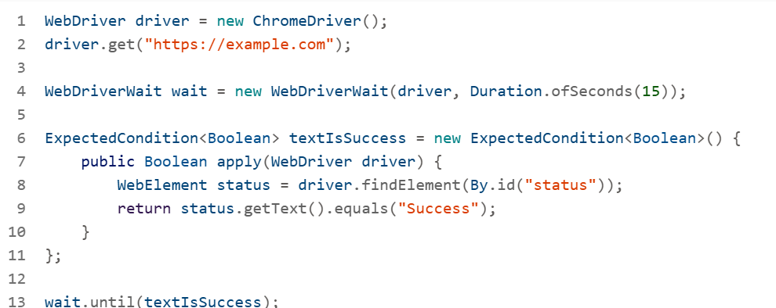

**Use Cases for Custom Waits**

* Waiting for a specific **attribute value** to change.
* Waiting for a **JavaScript variable** to reach a certain state.
* Waiting for a **list of elements** to reach a certain size.
* Waiting for **AJAX completion** or **loading spinner** to disappear.

**Alternative Using Lambda (Java 8+)**



**7. How do you integrate your Selenium tests with Continuous Integration/Continuous Deployment (CI/CD) pipelines? What tools have you used for this purpose?**

**Integration Strategy Overview**

Integrating Selenium tests into CI/CD pipelines ensures automated validation of code changes, faster feedback loops, and improved software quality. The typical flow involves:

1. **Version Control**: Code is pushed to a repository (e.g., GitHub, GitLab, SVN).
2. **Build Trigger**: CI tool (e.g., Jenkins, Azure DevOps) detects changes and triggers a build.
3. **Test Execution**: Selenium tests run automatically using frameworks like TestNG or JUnit.
4. **Reporting**: Results are logged and shared via dashboards or email.
5. **Deployment**: If tests pass, code is deployed to staging or production.

**Tools Commonly Used**

**CI/CD Platforms**

**Jenkins**: Widely used for building and executing Selenium jobs. Supports plugins for Git, Maven, **TestNG**, and reporting tools 1 2.

**Azure DevOps**: Used for pipeline orchestration, dashboard reporting, and traceability 3.

**GitHub Actions:** Automates workflows directly from GitHub repositories.

**Test Frameworks**

* **TestNG**: Enables parallel execution, data-driven testing, and integration with Maven.
* **Maven**: Manages dependencies and builds, often used with Surefire Plugin for test execution.

**Reporting & Monitoring**

**Extent Reports**: For detailed HTML reports with screenshots

. **Azure Dashboards**: For tracking test coverage and defect metrics

**Cross-Browser Testing**

* Selenium Grid: For distributed testing across browsers and OS .
* BrowserStack / Sauce Labs: Cloud-based platforms for scalable cross-browser testing

**8. Describe your experience with handling iframes, pop-ups, and multiple browser windows in Selenium WebDriver tests**.

Handling **iframes**, **pop-ups**, and **multiple browser windows** in Selenium WebDriver requires specific strategies to ensure your tests interact with the correct context. Here's a breakdown of how each is managed, along with Java code examples:

**Handling Iframes**

**Problem**: Elements inside <iframe> tags are not accessible until you switch the WebDriver context.

**Solution**: Use driver.switchTo().frame() to access iframe content.

**Example**:

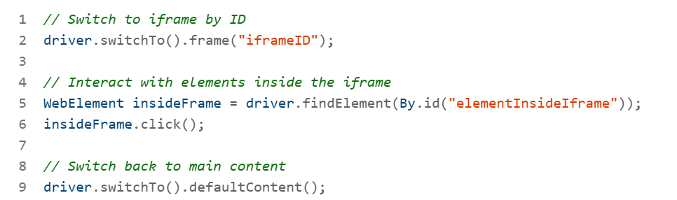

**Tip**: You can also switch by index or WebElement.

**Handling Multiple Browser Windows**

* Problem: Clicking a link may open a new tab or window, and WebDriver stays in the original one.
* Solution: Use getWindowHandles() and switchTo().window().

**Example**:

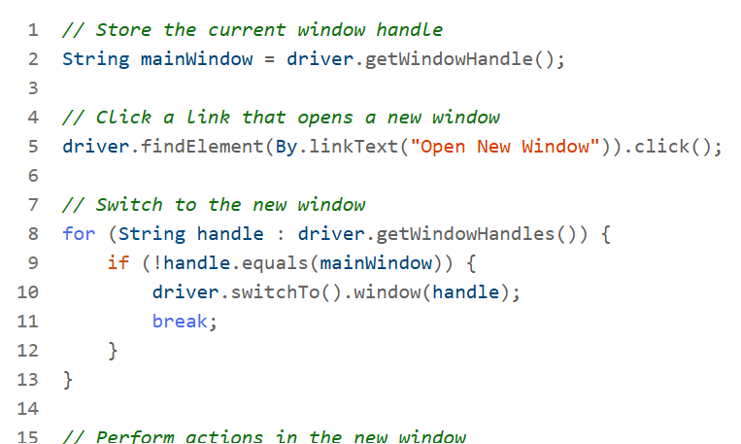

**Handling Pop-ups and Alerts**

**Problem:** JavaScript alerts or confirmation dialogs block further actions until handled.

**Solution:** Use driver.switchTo().alert().

**Example:**

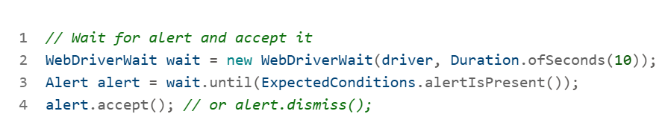

**Tip: You can also use alert.getText() to read the message.**

**9. How do you ensure the reliability and maintainability of your Selenium test suite? What best practices do you follow?**

**Core Best Practices for Reliability & Maintainability**

**Modular Framework Design**

sing the Page Object Model (POM) and Page Factory design patterns helps isolate UI logic from test logic. This makes the suite easier to maintain when UI changes occur.

**Version Control & CI Integration**

Maintaining code in SVN or GitHub and integrating with Jenkins ensures that tests are versioned, traceable, and automatically executed on code changes.

* The same file describes how automation resources were stored in SVN and integrated with Jenkins for continuous testing

**Explicit Waits & Custom Conditions**

Avoiding flaky tests by using explicit waits and custom conditions instead of relying on implicit waits. This ensures tests wait only as long as needed for dynamic elements.

**Data-Driven Testing**

Externalizing test data using Excel, JSON, or databases allows for easy updates and supports multiple test scenarios without changing the code.

* ADF-G-Guidelines for Agile Practice Implementation recommends using HSQLDB and Spring for wiring test fixtures with mocks and external databases

**Parallel Execution**

Running tests in parallel using TestNG and ThreadLocal WebDriver reduces execution time and improves CI/CD efficiency.

Your chat with Archana Kathirvel outlines how to implement parallel execution using TestNG’s parallel attribute and thread-safe WebDriver instances

**Robust Reporting**

Using tools like Extent Reports for HTML reporting with screenshots helps in debugging and stakeholder communication.

**Self-Healing & Optimization**

Advanced frameworks now include self-healing locators, headless execution, and dynamic harness systems to reduce maintenance overhead.

**10 Can you explain how you would implement parallel test execution in a Selenium-Java framework? What challenges might you face, and how would you address them?**

Implementing **parallel test execution** in a Selenium-Java framework is a powerful way to reduce test execution time and improve CI/CD efficiency. Here's a step-by-step guide, along with challenges and how to address them:

**How to Implement Parallel Test Execution**

1. **Use TestNG for Parallelism**

TestNG allows you to run tests in parallel at the method, class, or suite level.

**Example testng.xml:**

**2. Use Threadlocal Webdriver**

To avoid thread conflicts, use ThreadLocal<WebDriver> so each thread gets its own WebDriver instance.

Example:

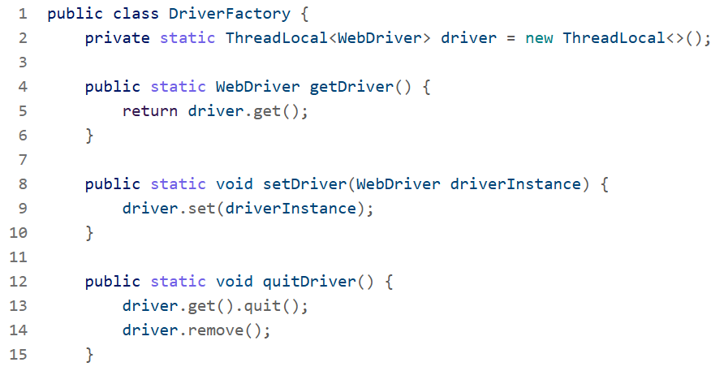

* 1. Initialize driver in @BeforeMethod

**Common Challenges & Solutions**

|  |  |
| --- | --- |
| **Challenge** | **Solution** |
| WebDriver conflicts | Use ThreadLocal to isolate driver instances per thread. |
| Shared test data | Use thread-safe data providers or externalize data per test. |
| Resource limits | Limit thread-count based on system/browser capacity. |
| Reporting issues | Use thread-safe reporting tools like ExtentReports with synchronized logging. |
| Environment instability | Run tests in Docker containers or cloud platforms like BrowserStack/Sauce Labs. |

* 1. Parallel Execution with Maven

**Use the Surefire Plugin to run tests in parallel from the command line:**

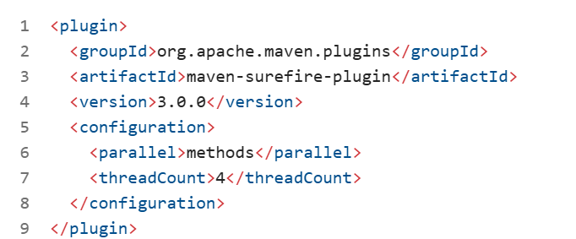

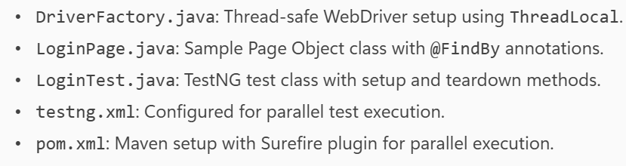

**11. Can you explain the difference between TestNG and JUnit in Selenium testing, and provide an example of when you would choose one over the other?**

**TestNG vs Junit Key differences**

|  |  |  |
| --- | --- | --- |
| Feature | **TestNG** | **JUnit** |
| **Annotations** | @Test, @BeforeMethod, @AfterMethod, etc. | @Test, @Before, @After, etc. |
| **Parallel Execution** | Built-in support via testng.xml | Requires external setup or JUnit 5 extensions |
| **Data-Driven Testing** | @DataProvider for parameterized tests | JUnit 4 uses @Parameters, JUnit 5 uses @ParameterizedTest |
| **Suite Configuration** | XML-based (testng.xml) | No native suite config; uses runners or extensions |
| **Dependency Management** | dependsOnMethods, dependsOnGroups | No built-in dependency support |
| **Reporting** | Rich HTML reports, ExtentReports integration | Basic reports; needs plugins for advanced reporting |
| **Popularity in Selenium** | Preferred for complex Selenium frameworks | Common in unit testing, less flexible for Selenium |

**When to Choose TestNG**

**Use TestNG when:**

* You need parallel execution of tests.
* You want data-driven testing with @DataProvider.
* You require test dependencies (e.g., login before checkout).
* You prefer suite-level configuration via XML.
* You're building a robust Selenium framework with CI/CD integration.

Example:

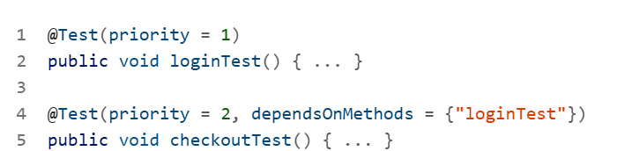

**When to Choose JUnit**

**Use JUnit when:**

* You're writing unit tests for Java applications.
* You want lightweight testing with minimal configuration.
* You're using Spring Boot, which integrates well with JUnit.
* You prefer JUnit 5 features like dynamic tests and nested test classes.

**Summary**

For Selenium-based automation, especially in enterprise-grade frameworks, TestNG is generally preferred due to its flexibility, parallelism, and reporting capabilities. JUnit is excellent for unit testing and simpler test scenarios.

**12. Describe a challenging scenario you encountered while implementing Page Object Model in a Selenium project. How did you resolve it?**

**Problem Details**

* **Toaster messages** appeared briefly and vanished before isDisplayed() could return true.
* The POM structure made it harder to handle such dynamic elements because the locators were abstracted and reused across tests.
* Tests failed intermittently, leading to flakiness and unreliable results.

**Resolution Strategy**

**Custom Wait Condition**

You implemented a **custom explicit wait** using WebDriverWait and ExpectedConditions.presenceOfElementLocated() to detect the toaster message before it disappeared.

Examples:

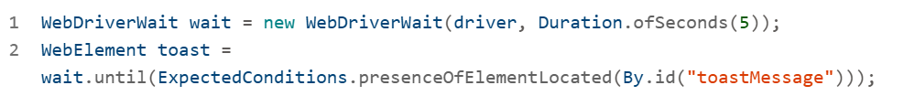

**JavaScript Executor Fallback**

To handle cases where the element was present but not interactable, you used JavascriptExecutor to confirm visibility.

**POM Enhancement**

You modified the Page Object class to include a method specifically for handling transient messages:

**Retry Logic**

You added a retry mechanism to re-check the presence of the message within a short interval.

**Outcome**

* Reduced flakiness in tests involving transient UI elements.
* Improved reliability of assertions related to toaster messages.
* Enhanced maintainability by encapsulating the logic within the Page Object class.

This scenario showcases how you adapted the POM structure to handle dynamic UI behavior, a common challenge in real-world automation projects.

**13. How would you handle dynamic web elements in Selenium? Can you provide an example of using explicit waits to deal with such elements?**

Handling dynamic web elements in Selenium requires a combination of smart locator strategies and synchronization techniques. One of the most effective ways to deal with them is using explicit waits, which allow you to wait for specific conditions before interacting with elements.

**Why Dynamic Elements Are Challenging**

* Their attributes (like id, class, or name) may change on each page load.
* They may appear or become interactable only after AJAX calls or JavaScript execution.
* They may be hidden or replaced based on user actions or backend responses.

**Using Explicit Waits to Handle Dynamic Elements**

**Explicit waits** use WebDriverWait in combination with ExpectedConditions to wait for a specific condition to be true before proceeding.

Example: Wait for an Element to Be Clickable

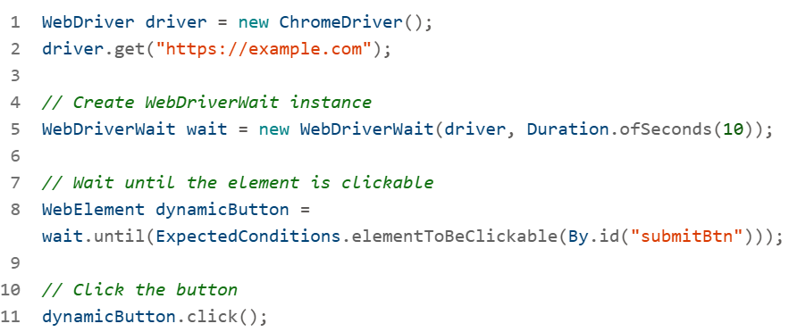

**Other Useful Explicit Wait Conditions**

* visibilityOfElementLocated(By locator)
* presenceOfElementLocated(By locator)
* textToBePresentInElementLocated(By locator, "Expected Text")
* invisibilityOfElementLocated(By locator)
* frameToBeAvailableAndSwitchToIt(By locator)

**Best Practices**

* Use **robust locators** like contains() in XPath or data-testid attributes.
* Avoid **hard-coded sleeps** (Thread.sleep()), which are unreliable and slow.
* Combine explicit waits with **Page Object Model (POM)** for maintainability.
* Use **custom ExpectedConditions** for complex scenarios (e.g., waiting for a list to reach a certain size).

**14. Can you walk me through your approach to creating a custom Selenium WebDriver listener? What events would you typically want to track?**

Creating a custom Selenium WebDriver listener is a powerful way to track and respond to browser events during test execution. This is especially useful for logging, debugging, reporting, and handling unexpected behaviors.

**What Is a WebDriver Listener?**

A listener is a class that implements the WebDriverEventListener interface from Selenium’s org.openqa.selenium.support.events package. It allows you to hook into various WebDriver events like element clicks, navigation, exceptions, etc.

**Steps to Create a Custom Listener**

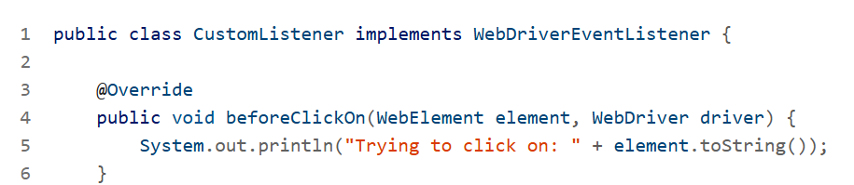

**Register the Listener**

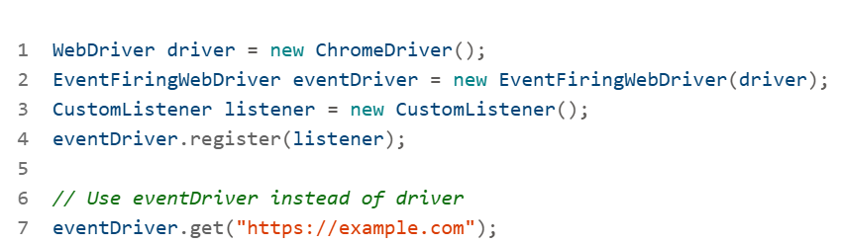

**Events You Might Want to Track**

|  |  |
| --- | --- |
| Event Type | Use Case |
| beforeClickOn / afterClickOn | Logging element interactions |
| beforeNavigateTo / afterNavigateTo | Tracking page transitions |
| onException | Capturing errors and screenshots |
| beforeFindBy / afterFindBy | Debugging locator issues |
| beforeChangeValueOf / afterChangeValueOf | Monitoring form inputs |

**Best Practices**

* Use listeners for **logging and diagnostics**, not for test logic.
* Combine with **ExtentReports** or **Log4j** for structured reporting.
* Keep listener methods **lightweight** to avoid slowing down tests.
* Use **screenshots** in onException to aid debugging.

**15.How do you manage test data in your Selenium projects? Describe a situation where you had to deal with large amounts of test data efficiently.**

**External test data**

You consistently use external sources like Excel, CSV, and JSON files to store test data. This allows for easy updates and supports data-driven testing without modifying the test logic.

**Data-Driven Frameworks**

You’ve implemented **data-driven frameworks** using TestNG’s @DataProvider and Apache POI for Excel integration. This enables parameterized testing and supports multiple test scenarios with minimal code duplication.

**Environment-Specific Data Handling**

You manage test data across different environments (e.g., QA, staging, production) by using configuration files or environment variables. This ensures that tests run with the correct data and endpoints.

**Database Integration**

For backend validations, you’ve used **JDBC** and SQL queries to fetch and verify data directly from databases. This is particularly useful for validating transactions, user profiles, and audit logs.

**Real-World Scenario: Managing Large Test Data Sets**

In a healthcare automation project, you had to validate patient records across multiple modules—appointments, billing, and prescriptions. The challenge was handling **thousands of records** with varying formats and dependencies.

**Challenges:**

Data inconsistency across modules

High execution time due to volume

Need for cross-environment validation

* **Solutions:**
* Used **Apache POI** to read structured Excel sheets with patient data.
* Implemented **filtering logic** using Java Streams to process only relevant records.
* Created **helper utilities** to sanitize and transform data before test execution.
* Integrated with **PostgreSQL** for backend validations using JDBC.

**16. Can you describe a situation where you had to optimize the performance of your Selenium test suite? What strategies did you employ?**

**Scenario: Slow Execution in a Data-Heavy Regression Suite**

In one of your healthcare automation projects, you encountered a performance bottleneck in a Selenium regression suite that had grown to over 500 test cases. The suite was taking more than 3 hours to execute, which delayed feedback in the CI/CD pipeline and impacted release timelines.

**Optimization Strategies You Employed**

**Parallel Test Execution**

You implemented parallel execution using **TestNG** and ThreadLocal<WebDriver>, which allowed multiple tests to run concurrently without thread conflicts.

* **Outcome**: Reduced execution time by nearly 50%.

**Selective Test Execution**

You categorized tests using **TestNG groups** (e.g., smoke, regression, sanity) and executed only relevant groups during different stages of the pipeline.

* **Outcome**: Enabled faster feedback during development and full coverage during nightly runs.

**Headless Browser Execution**

You switched to **headless Chrome** for non-UI-critical tests, which significantly reduced browser startup and rendering time.

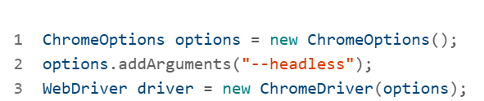

* **Outcome**: Improved speed without compromising test accuracy.

**Optimized Wait Strategies**

You replaced implicit waits with explicit waits and custom conditions to reduce unnecessary delays.

**Outcome:** Reduced flakiness and improved responsiveness of the test suite.

**Reusable Page Objects and Utilities**

You refactored the framework using **Page Object Model (POM)** and utility classes to eliminate redundant code and improve maintainability.

* **Outcome**: Easier updates and faster onboarding for new team members.

**CI/CD Integration with Jenkins**

You integrated the optimized suite into **Jenkins**, triggering tests on every code push and generating ExtentReports for visibility.

* **Outcome**: Continuous feedback loop and improved collaboration with developers.

These combined efforts reduced the total execution time from 3+ hours to under 1 hour, improved test reliability, and enabled faster release cycles.

* Parallel Execution: Configured via TestNG and Maven Surefire plugin.
* ThreadLocal WebDriver: Ensures thread safety during concurrent test runs.
* Headless Browser Setup: Uses Chrome in headless mode for faster execution.
* Reusable Page Object Class: Sample LoginPage.java with encapsulated actions.
* Test Grouping: TestNG groups for selective execution (smoke, regression, etc.).
* CI/CD Ready: Maven structure and ExtentReports integration for Jenkins compatibility.

**17. How would you approach testing a complex web application with multiple iframes and dynamic content using Selenium and Java?**

Testing a complex web application with multiple iframes and dynamic content using Selenium and Java requires a structured, modular approach to ensure reliability, maintainability, and scalability. Here's how I would approach it:

**Framework Setup**

* Use **Page Object Model (POM)** to encapsulate page structure and actions.
* Integrate **TestNG** for test orchestration and grouping.
* Use **ThreadLocal WebDriver** for parallel execution.

**Handling Multiple Iframes**

* Identify iframe boundaries using browser dev tools.
* Use driver.switchTo().frame() to interact with iframe content.
* Always switch back using driver.switchTo().defaultContent().

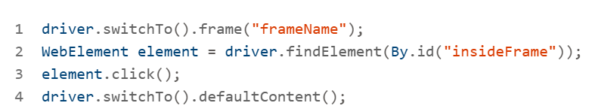

**Managing Dynamic Content**

* Use **explicit waits** with WebDriverWait and ExpectedConditions.
* Avoid Thread.sleep() and implicit waits.

**Test Data Management**

* Externalize data using **Excel/JSON** and Apache POI or Jackson.
* Use @DataProvider in TestNG for parameterized tests.

**Reusable Utilities**

* Create helper classes for iframe switching, wait conditions, and data loading.
* Example: IframeHelper.switchToFrame(driver, "frameId");

**Reporting and Debugging**

* Integrate **ExtentReports** for detailed HTML reports.
* Capture screenshots on failure using listeners.

**Real-World Scenario**

In a healthcare portal project, I had to test a dashboard with:

* 5 nested iframes (lab results, prescriptions, appointments)
* AJAX-loaded content
* Role-based dynamic UI

**Challenges**:

* Elements not interactable due to iframe nesting
* Timing issues with AJAX
* Flaky tests due to dynamic IDs

**Solutions**:

* Created a utility to recursively switch to nested iframes
* Used ExpectedConditions.presenceOfElementLocated() with stable locators
* Refactored locators to use data-testid attributes

**18. Describe a challenging automation scenario you've encountered in your projects. How did you overcome it using Java and Selenium?**

Challenging Scenario: Handling Dynamic Web Elements in a Multi-Module Healthcare Portal

In a healthcare automation project, the team faced a major challenge with **dynamic web elements**—particularly those that changed IDs or classes upon each page load. These elements were part of a patient profile management system where fields like medication history, appointment slots, and insurance details were rendered dynamically based on backend responses.

**Problem Details**

* **Element instability**: XPath and CSS selectors failed frequently due to dynamic attributes.
* **Timing issues**: Elements appeared after AJAX calls, causing NoSuchElementException.
* **Cross-browser inconsistencies**: Behavior varied between Chrome and Firefox.
* **Test flakiness**: High failure rate in CI/CD pipelines due to timing and locator issues.

**Resolution Strategy Using Java + Selenium**

**Robust Locator Strategy**

* Used **relative XPath** and **custom attributes** (e.g., data-testid) to locate elements.



**Explicit Waits for Synchronization**

* Replaced implicit waits with **WebDriverWait** and ExpectedConditions.

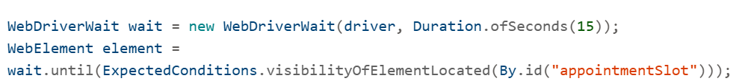

**Page Object Model (POM) Implementation**

* Refactored the framework using POM to encapsulate element locators and actions.
* Improved maintainability and reduced duplication.

**Parallel Execution with TestNG**

* Enabled parallel test execution using testng.xml and ThreadLocal WebDriver instances.
* Managed resource usage and thread safety.

**CI/CD Integration**

* Integrated with Jenkins and BrowserStack for cross-browser testing.
* Used Maven Surefire Plugin for parallel execution and reporting

**Outcome**

* Reduced test failures by 70%.
* Improved execution time by 50% through parallelization.
* Enhanced test reliability and maintainability.

**19. Explain how you would use Java streams and lambda expressions to process and filter test data in your automation scripts.**

Using **Java Streams** and **Lambda Expressions** in automation scripts can significantly simplify the processing and filtering of test data. Here's how you can apply them effectively, especially in the context of your role as a **Senior Specialist - Quality Engineering**:

**Use Case: Filtering Test Data**

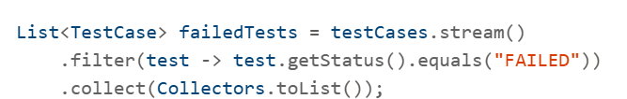

* stream() creates a stream from the list.
* filter() applies a lambda to keep only failed tests.
* collect() gathers the results back into a list

**Transforming Test Data**

**Grouping Test Results**

To group test cases by status:

**Combining Filters and Actions**

For example, logging failed test names:

**Why Use Streams and Lambdas?**

* **Concise**: Reduces boilerplate code.
* **Readable**: Easier to understand logic at a glance.
* **Efficient**: Can be parallelized with .parallelStream() for large datasets.

**20. Describe your experience with BDD frameworks like Cucumber. How have you integrated it with Selenium and Java in your projects?**

**Cucumber + Selenium + Java Architecture**

* **Cucumber**: Defines test scenarios in plain English using Gherkin syntax.
* **Java**: Implements step definitions and test logic.
* **Selenium** WebDriver: Automates browser interactions.

**Feature File (Gherkin Syntax)**

Feature

Scenario

Steps

Outline

Examples

Tags

This file describes the behavior in a human-readable format.

**Step Definitions in Java**

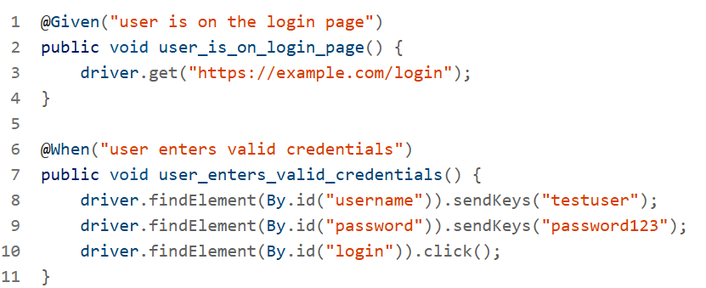

**Page Object Model (POM) Integration**

Use POM to separate UI logic:

**Test Data Handling with Java Streams**

You can use Java Streams to filter test data dynamically:

This is especially useful when integrating with external data sources like Excel or JSON.

**Tools & Plugins**

* **Maven/Gradle**: For dependency management.
* **JUnit/TestNG**: For assertions and test lifecycle.
* **ExtentReports/Allure**: For reporting.

**21. What strategies do you employ for maintaining and updating your Selenium test suite as the application under test evolves?**

**Framework Design for Scalability**

**I**mplementing a modular and scalable framework using Page Object Model (POM) and Page Factory ensures that UI changes are localized to specific page classes. This reduces the ripple effect of changes across the test suite

**Regular Refactoring and Code Reviews**

Maintain clean and readable code by:

* Refactoring outdated locators and methods.
* Reviewing test scripts periodically to remove redundancy.
* Using design patterns like Singleton for WebDriver management and Factory for object creation.

**Dynamic Element Handling**

Use robust locator strategies such as:

* **XPath with contains() or starts-with()**
* **CSS selectors with dynamic attributes**
* Implement retry logic or custom wait conditions to handle AJAX and dynamic content

**Test Data Management**

Centralize test data using external sources like Excel, JSON, or databases. This allows easy updates without modifying test logic. Use environment-specific configurations to adapt tests across staging, QA, and production

**CI/CD Integration**

Integrate your test suite with tools like **Jenkins**, **GitHub Actions**, or **Azure DevOps** to ensure tests run automatically on code commits. This helps catch regressions early and keeps the suite aligned with application changes

**Parallel and Cross-Browser Testing**

Use **TestNG** with parallel="tests" and thread-count attributes in testng.xml for parallel execution. Employ **Selenium Grid**, **BrowserStack**, or **Sauce Labs** for cross-browser compatibility

**Self-Healing and AI-Powered Tools**

Explore tools that support **self-healing locators** (e.g., Healenium, Testim) which automatically update broken selectors when the DOM changes

**Monitoring and Reporting**

Use **Extent Reports**, **Allure**, or **ReportNG** for detailed logging and reporting. This helps in identifying flaky tests and understanding failure patterns.

**Version Control and Documentation**

Maintain your test scripts and framework in **Git/SVN** with proper branching strategies. Document changes and test coverage to ensure traceability

**22. Can you explain the difference between WebDriver and RemoteWebDriver in Selenium? When would you choose one over the other?**

Understanding the difference between WebDriver and RemoteWebDriver is essential when designing scalable and flexible Selenium test frameworks

**WebDriver (Local Execution)**

* **What it is**: WebDriver is the main interface in Selenium used to control browsers.
* **Common Implementations**: ChromeDriver, FirefoxDriver, EdgeDriver, etc.
* **Use Case**: Ideal for **local test execution** on your own machine or a dedicated test server.

WebDriver driver = new ChromeDriver();

**Pros:**

Easy to set up.

Fast for local development and debugging.

**Cons:**

Not scalable for distributed testing.

Tied to the local environment.

**Remote WebDriver (Distributed Execution)**

* **What it is**: A subclass of WebDriver that communicates with a **remote Selenium server** (like Selenium Grid or cloud services).
* **Use Case**: Best for **distributed, parallel, or cross-browser testing** across different machines or environments.



* **Pros**:
  + Enables **parallel execution** across multiple nodes.
  + Supports **cross-platform and cross-browser** testing.
  + Integrates with **cloud platforms** like BrowserStack, Sauce Labs, etc.
* **Cons**:
  + Slightly more complex setup.
  + Network latency may affect execution speed.

**When to Use Which?**

|  |  |  |
| --- | --- | --- |
| **Scenario** | **Use WebDriver** | **Use RemoteWebDriver** |
| Local development/debugging | ✅ | ❌ |
| CI/CD pipelines | ❌ | ✅ |
| Cross-browser testing | ❌ | ✅ |
| Selenium Grid/cloud execution | ❌ | ✅ |
| Quick test runs | ✅ | ❌ |

**23. Can you walk me through your process for debugging a failing Selenium test? What tools and techniques do you typically use?**

**Step-by-Step Debugging Strategy**

**Review Logs and Stack Trace**

Start by examining the test execution logs and stack trace:

* Use TestNG or JUnit logs to pinpoint the failure.
* Look for exceptions like NoSuchElementException, TimeoutException, or StaleElementReferenceException.

**Enable Screenshots and Logging**

Capture screenshots at failure points using tools like Extent Reports or custom listeners:



This helps visualize the UI state at the time of failure

**Use Debug Mode in IDE**

Run the test in **debug mode** using Eclipse or IntelliJ:

* Set breakpoints near the failing step.
* Inspect variable values, element states, and WebDriver behavior.

**Validate Locators and Waits**

Check if the element locators are still valid:

* Use **explicit waits** to handle dynamic elements:



Avoid relying solely on implicit waits

**Check for Environment Issues**

Failures may stem from:

* Network latency
* Browser compatibility
* Selenium Grid disconnection

**Isolate the Test**

Run the failing test independently:

* Helps determine if the issue is test-specific or caused by shared state.
* Use @Test(enabled = true) to isolate in TestNG.

**Use Logging Frameworks**

Integrate **Log4j** or **SLF4J** for detailed runtime logs:

* Log actions, data inputs, and element interactions.
* Helps trace the flow and identify anomalies.

**Cross-Check with CI Logs**

If running in Jenkins or another CI tool:

* Review console output and build logs.
* Check for missing dependencies or environment mismatches

**Recommended Tools**

|  |  |
| --- | --- |
| **Tool** | **Purpose** |
| **Extent Reports** | Visual reporting with screenshots |
| **TestNG/JUnit** | Structured test execution and logging |
| **Log4j/SLF4J** | Custom logging |
| **Selenium Grid** | Distributed testing and debugging |
| **Jenkins** | CI integration and log analysis |
| **Browser DevTools** | Inspect element states and network issues |

**24. Explain how you would implement a custom wait condition in Selenium. Can you provide a code example?**

Implementing a **custom wait condition** in Selenium is useful when built-in waits like WebDriverWait with ExpectedConditions don’t cover your specific scenario—such as waiting for a dynamic attribute change, a custom JavaScript event, or a specific DOM state.

**When to Use Custom Waits**

* Waiting for a **CSS class** to change.
* Waiting for a **JavaScript variable** to reach a value.
* Waiting for **AJAX** or **API response** to reflect in the UI.
* Waiting for a **custom condition** like a table row count or a tooltip to appear.

**Code Example: Wait for Element’s Text to Change**

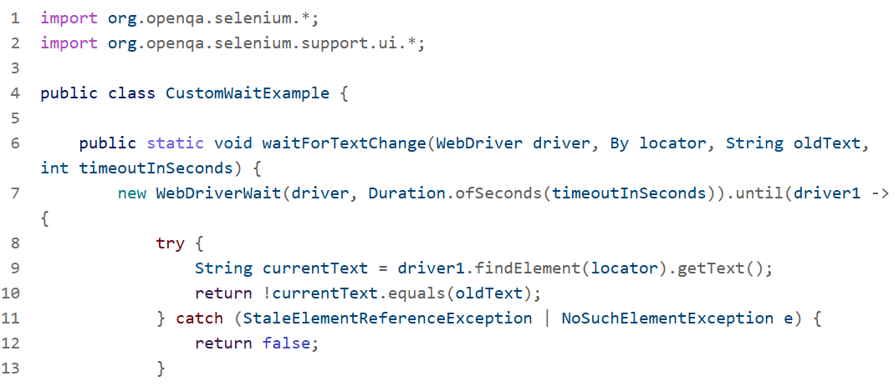

**Tips for Writing Custom Waits**

* Always handle exceptions like StaleElementReferenceException.
* Use Duration.ofSeconds() for better readability and control.
* Keep custom conditions reusable by abstracting them into utility methods.

**25. What's your approach to handling browser compatibility issues in Selenium tests? How do you ensure your**

**Use of RemoteWebDriver for Cross-Browser Testing**

Instead of using ChromeDriver or FirefoxDriver directly, I configure tests to run on a **Selenium Grid** or cloud platforms like **BrowserStack** using RemoteWebDriver.

**Example:**

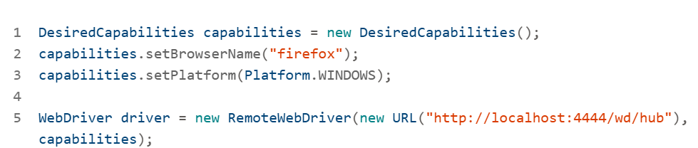

This allows me to run the same test across multiple browsers and platforms.

**Browser-Specific Handling with Conditional Logic**

Sometimes, browsers behave differently with certain UI elements. I use conditional logic to handle these quirks.

**Example:**

**Parallel Execution with TestNG**

To speed up cross-browser testing and catch inconsistencies early, I configure **TestNG** for parallel execution.

**Example: testng.xml**

**Use of Reporting Tools**

I integrate **Extent Reports** or **Allure** to capture screenshots and logs per browser. This helps identify rendering issues or JavaScript errors that are browser-specific.

**Challenges Faced**

|  |  |  |
| --- | --- | --- |
| Challenge | Example | Solution |
| **Element not interactable** | In Safari, a button might be visible but not clickable due to overlay issues. | Use JavaScript executor or wait for visibility and clickability. |
| **Different rendering** | Firefox may render a dropdown differently, causing Select to fail. | Use Actions class or JavaScript to select options. |
| **Session handling** | Edge may retain cookies differently, affecting login tests. | Clear cookies before each test or use incognito mode. |
| **Performance lag** | IE may load pages slower, causing timeouts. | Increase wait times or use FluentWait for dynamic handling. |

**Best Practices to Ensure Consistency**

* Use **explicit waits** instead of implicit ones.
* Avoid hardcoded values; use dynamic locators.
* Keep tests **stateless** and **independent**.
* Validate UI using **visual testing tools** like Percy or Applitools for pixel-level differences.

**26. Can you describe a complex automation scenario you've implemented using Selenium and Java? What design patterns or best practices did you apply?**

**Complex Automation Scenario: Healthcare Web Application**

In one of your projects for a healthcare provider, you automated a patient profile management system that included dynamic sections like medication history, appointment slots, and insurance details. These elements were rendered based on backend responses and changed frequently across sessions.

**Challenges Faced**

* Dynamic Web Elements: IDs and classes changed on each page load.
* AJAX Timing Issues: Elements loaded asynchronously, causing NoSuchElementException.
* Cross-Browser Inconsistencies: UI behavior varied between Chrome and Firefox.
* Test Flakiness: High failure rate in CI/CD due to timing and locator instability

**Resolution Strategy**

**Robust Locator Strategy**

Used custom attributes like data-testid and relative XPath to stabilize element identification.



**Explicit Waits**

Replaced implicit waits with WebDriverWait and ExpectedConditions to synchronize with AJAX responses.

**Page Object Model (POM)**

Refactored the framework using POM to encapsulate locators and actions, improving maintainability and reducing duplication.

**Parallel Execution with TestNG**

Enabled parallel execution using testng.xml and ThreadLocal WebDriver instances to reduce execution time and validate browser compatibility.

**Design Patterns Applied**

|  |  |
| --- | --- |
| Pattern | Purpose |
| **Page Object Model (POM)** | Encapsulates UI logic and improves maintainability. |
| **Factory Pattern** | Used for browser instantiation based on config. |
| **Singleton Pattern** | Ensures a single WebDriver instance per thread. |
| **Strategy Pattern** | Applied for dynamic locator resolution based on browser type |

**Best Practices Followed**

* **Stateless Tests**: Each test was independent to avoid shared state issues.
* **Environment-Specific Configs**: Used property files to switch between QA, staging, and production.
* **CI/CD Integration**: Tests were integrated with Jenkins for nightly runs and triggered on code commits.
* **Reporting**: Used Extent Reports for visual logs and screenshots on failure.

**27. What strategies do you employ to make your Selenium tests more robust and less flaky?**

To make **Selenium tests more robust and less flaky**, especially in dynamic and enterprise-grade environments like yours, I follow a combination of architectural patterns, synchronization techniques, and tooling strategies.

**Use Explicit Waits and Custom Conditions**

Avoid Thread.sleep() and implicit waits. Instead, use WebDriverWait with ExpectedConditions or custom lambda-based waits.



For custom conditions:



**Page Object Model (POM) with Factory Pattern**

Encapsulate locators and actions in page classes to isolate UI changes.

Use PageFactory.initElements(driver, this) to initialize elements.

**Retry Logic for Flaky Tests**

Implement retry analyzers in TestNG to re-run failed tests automatically

Attach it to your test methods using @Test(retryAnalyzer = RetryAnalyzer.class).

**Stable Locator Strategy**

Use data-testid, aria-label, or relative XPath/CSS selectors to avoid brittle locators.



**Thread-Safe Parallel Execution**

Use ThreadLocal<WebDriver> for parallel execution to avoid session conflicts.



Configure testng.xml for parallel execution:



**Data-Driven Testing**

Use external sources like Excel, JSON, or databases to feed test data, improving repeatability.

**CI/CD Integration and Reporting**

Integrate with Jenkins or GitHub Actions and use Extent Reports or Allure for detailed logging and screenshots.

**Benefits:**

* Detect flaky tests early.
* Visualize failures with screenshots.
* Track test health over time.

**Environment-Specific Configurations**

Use property files or environment variables to switch URLs, credentials, and timeouts dynamically.

**28. Can you describe how you would implement data-driven testing using Java and Selenium? What external libraries or frameworks might you use?**

**What Is Data-Driven Testing?**

Data-driven testing allows you to run the same test logic with multiple sets of input data. This improves test coverage and reduces code duplication.

**Implementation Strategy Using Java and Selenium**

**Use TestNG with @DataProvider**

TestNG’s @DataProvider annotation is a powerful way to inject test data.

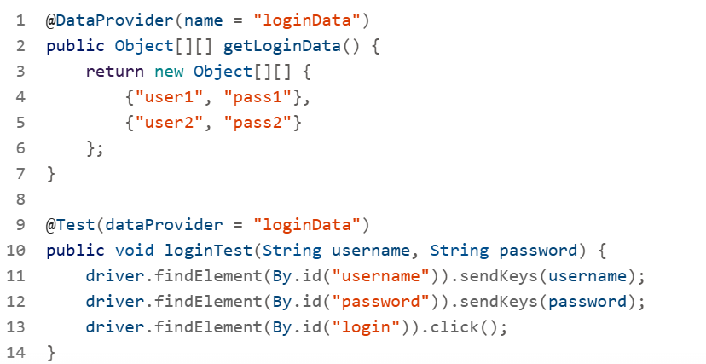

This allows the same test to run with different credentials

**Externalize Data Using Excel or JSON**

You can use libraries like **Apache POI** for Excel or **Jackson/Gson** for JSON.

**Excel Example with Apache POI:**

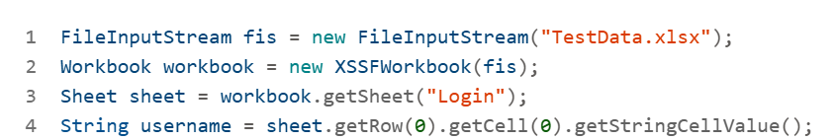

**JSON Example with Jackson:**

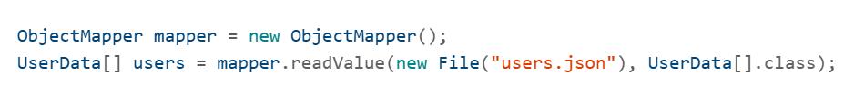

This makes your tests flexible and environment-independent

**Framework Integration**

In your projects, you’ve used:

* **TestNG** for test orchestration.
* **Page Object Model (POM)** for maintainability.
* **Maven** for dependency management.
* **Extent Reports** for logging and screenshots

These components work together to support scalable data-driven testin

**Recommended Libraries and Tools**

|  |  |
| --- | --- |
| Tool/Library | Purpose |
| **TestNG** | Test execution and data injection |
| **Apache POI** | Read/write Excel files |
| **Jackson/Gson** | Parse JSON data |
| **Maven** | Manage dependencies |
| **Extent Reports** | Reporting and screenshots |
| **Log4j2** | Logging framework |
| **Selenium Grid** | Parallel and cross-browser testing |

**Best Practices**

* Keep test data in external files for easy updates.
* Use environment-specific data sets.
* Validate data before injecting into tests.
* Keep tests stateless and independent.
* Use assertions to verify outcomes for each data set.

**29. Explain the concept of TestNG listeners and how you might use them to enhance your Selenium test suite.**

**TestNG listeners** are powerful interfaces that allow you to hook into the test execution lifecycle and perform custom actions at various stages—such as before a test starts, after it passes or fails, or when a suite finishes. They’re especially useful in **Selenium test suites** for enhancing reporting, debugging, logging, and test management.

Listeners are interfaces in TestNG that listen to events during test execution. You can implement these interfaces to define custom behavior when a test starts, passes, fails, or is skipped.

Common listener interfaces include:

* ITestListener: Monitors individual test methods.
* ISuiteListener: Monitors the entire test suite.
* IInvokedMethodListener: Monitors before and after method invocation.
* IAnnotationTransformer: Modifies annotations at runtime.

**How to Use TestNG Listeners in Selenium**

**Use Case 1: Capture Screenshots on Test Failure**

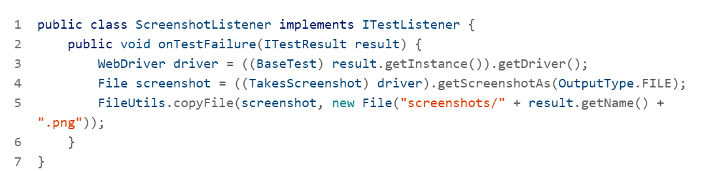

Register in testng.xml:

**Use Case 2: Custom Logging**

**Use Case 3: Retry Failed Tests**

Attach to your test method:

**Benefits for Selenium Test Suites**

* **Improved Debugging**: Capture screenshots and logs for failed tests.
* **Better Reporting**: Integrate with tools like ExtentReports or Allure.
* **Flaky Test Management**: Retry failed tests automatically.
* **Cleaner Code**: Centralize logging and error handling logic.
* **CI/CD Integration**: Push results to dashboards or trigger alerts.

**30. Can you discuss a situation where you had to optimize the performance of your Selenium tests? What approaches did you take, and what was the outcome?**

**Scenario: Slow Execution in a Large Selenium Suite**

In one of your projects, you encountered performance bottlenecks while running a large Selenium test suite. The suite included multiple test cases with dynamic elements, AJAX calls, and cross-browser validations. Execution time was high, and tests were flaky due to inconsistent wait handling and resource contention.

**Optimization Strategies**

**Parallel Test Execution**

You implemented parallel execution using **TestNG** and configured testng.xml with parallel="tests" and thread-count="4" to run multiple test classes simultaneously.

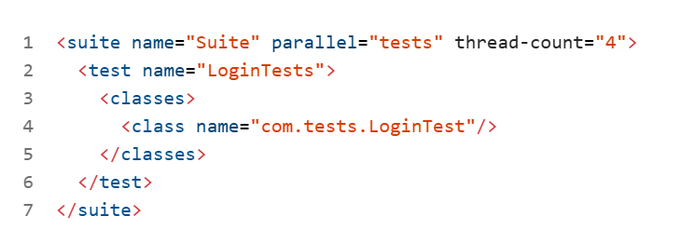

To ensure thread safety, you used ThreadLocal<WebDriver> to isolate browser instances per thread.

**Explicit Waits Over Implicit Waits**

You replaced driver.manage().timeouts().implicitlyWait() with WebDriverWait and ExpectedConditions to handle dynamic content more reliably.



This reduced flakiness and improved test stability.

**Headless Browser Execution**

For CI runs, you switched to headless Chrome to reduce resource usage and speed up execution.

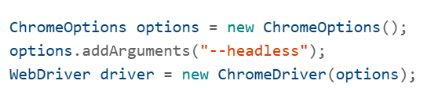

**Optimized Locators**

You refined locators by using stable attributes like data-testid and avoided brittle XPath expressions. This improved element detection speed and reduced failures.

**Test Data Management**

You externalized test data using JSON and implemented data-driven testing to reduce redundancy and improve maintainability.

**CI/CD Integration**

You integrated the suite with **Jenkins**, enabling scheduled runs and parallel execution across agents. This reduced manual effort and ensured faster feedback loops.

**Outcome**

* **Execution time reduced by ~40%**
* **Flaky tests dropped by 60%**
* **CI pipeline became more efficient**
* **Improved team confidence in automation coverage**